**DAILY ONLINE ACTIVITIES SUMMARY**

|  |  |  |  |  |  |  |  |  |
| --- | --- | --- | --- | --- | --- | --- | --- | --- |
| **Date:** | **25/06/2020** | | | | | **Name:** | **POOJA D S** | |
| **Sem & Sec** | **IV Sem & B section** | | | | | **USN:** | **4AL18CS056** | |
| **Online Test Summary** | | | | | | | | |
| **Subject** | | **-** | | | | | | |
| **Max. Marks** | | **30** | | **Score** | | | **-** | |
| **Certification Course Summary** | | | | | | | | |
| **Course** | **Introduction to Programming** | | | | | | | |
| **Certificate Provider** | | | **Great learning academy** | | **Duration** | | | **5.5hours** |
| **Coding Challenges** | | | | | | | | |
| **Problem Statement1:** Write a C Program to reverse the rows in a 2d Array. | | | | | | | | |
| **Status: Executed** | | | | | | | | |
| **Uploaded the report in Github** | | | | | **Yes** | | | |
| **If yes Repository name** | | | | | <https://github.com/dspooja/C-coding> | | | |
| **Uploaded the report in slack** | | | | | **Yes** | | | |

Online Test Summary: No internals conducted today.

Online Certification Course Summary: In today’s session I have learnt about the Importance and Application of programming Language, Variables, Decision Making Statement, Looping Statement.

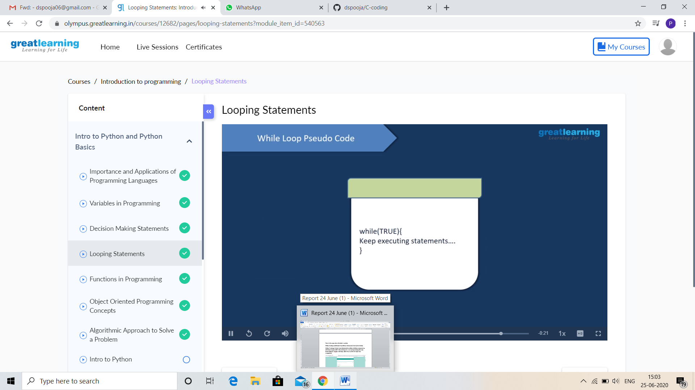

This is the snap shot of today’s session.

Yesterday I finish Introduction to Information Security Certificate Course and attend Quiz. This is my certificate

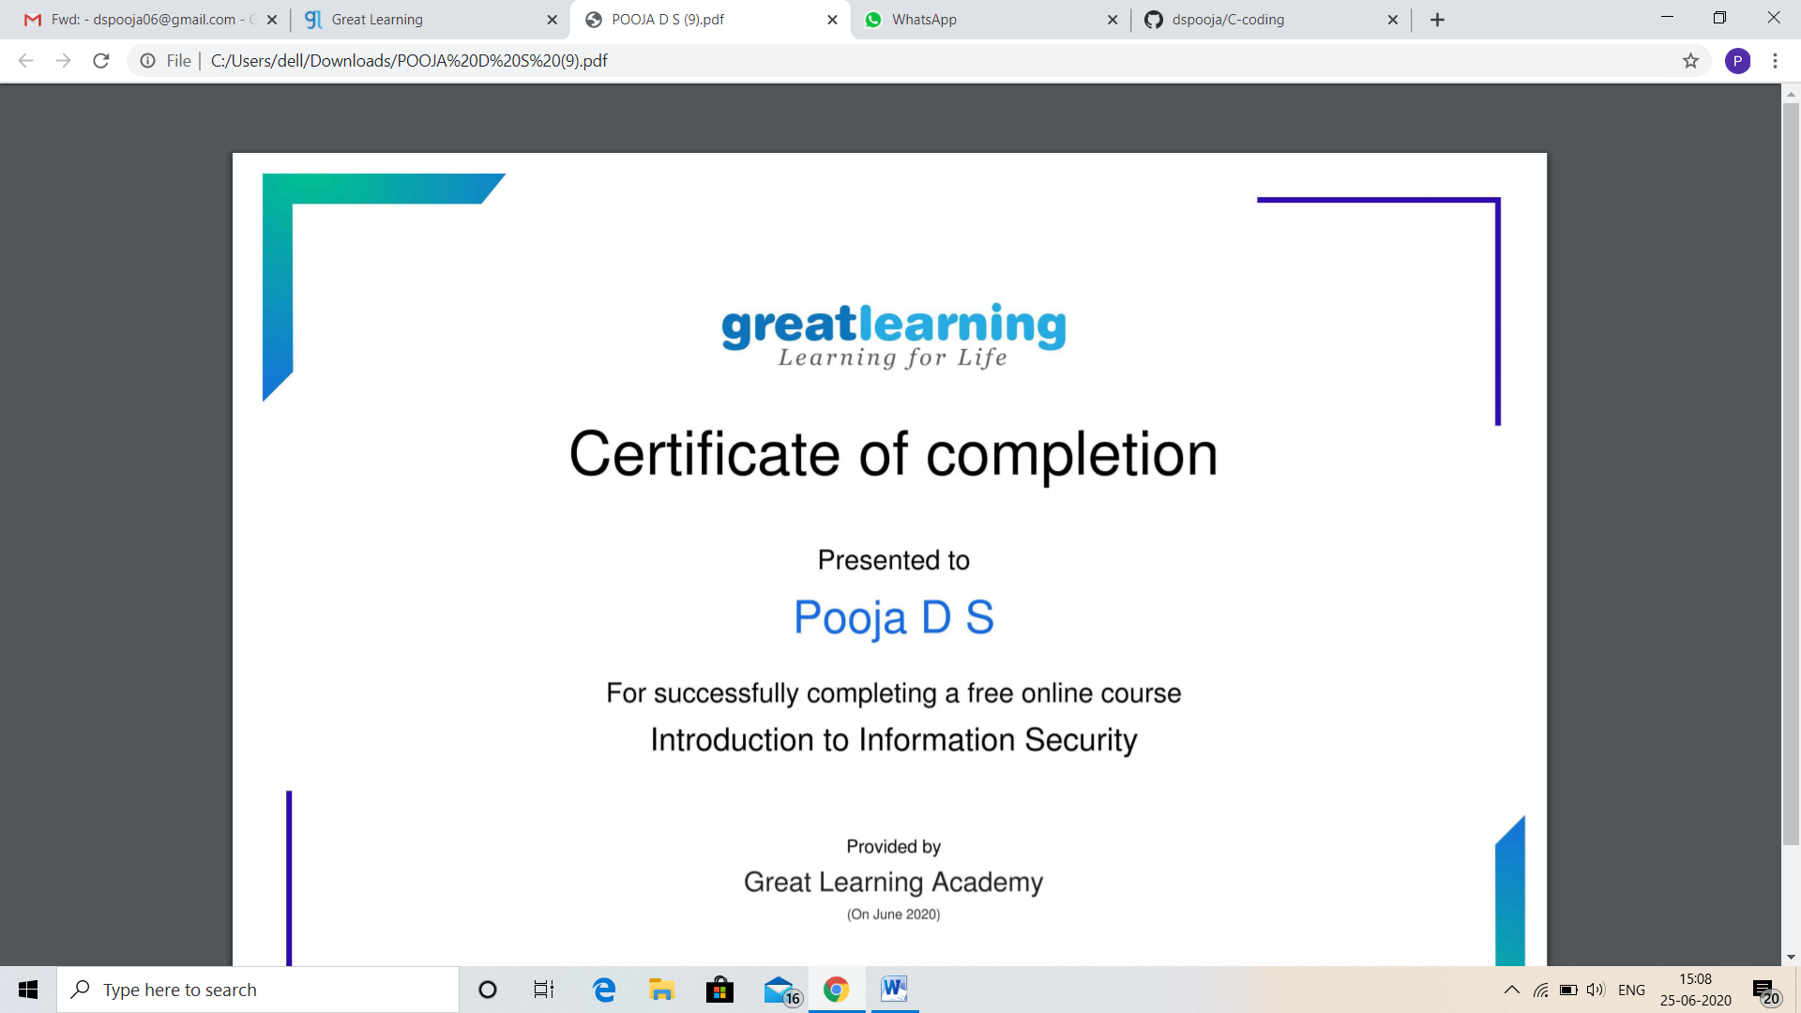

Online Coding Summary: Today I had received one program from Ms. Shilpa mam CSE Dept. The program is mention above in the coding challenges. I have also uploading it to my Github repository.

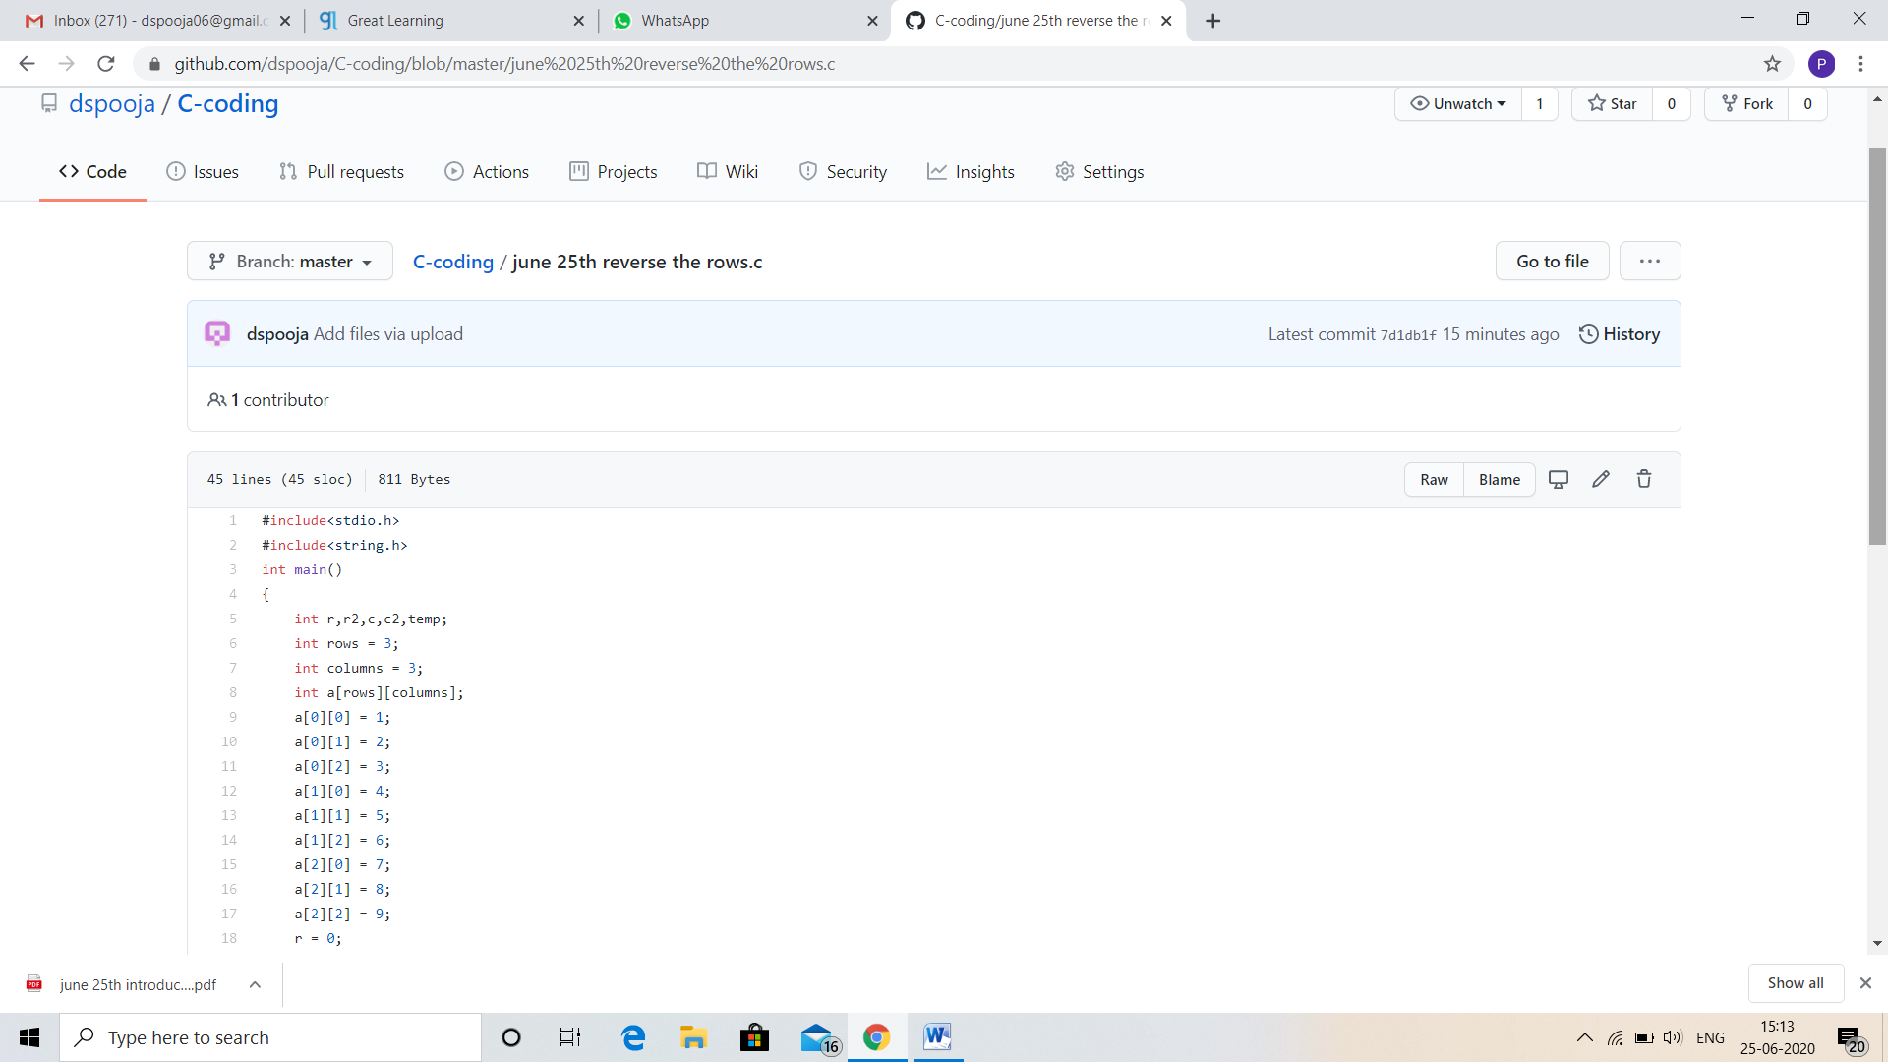

Online Training: Today I had attended the online training organized by CSE Department AIET. The training was on C++ programming done by Ms. Shruthi Shetty J mam CSE Dept. After the session the quiz was conducted.